**SAMET ÖZGÜL**

705201014

BBL536E Data Science

**Question 1**

Firstly, I read data from file using pandas read_excel command. The preprocessing steps are perform one by one. The data is splitted X, y_1 and y_1. X represents our features, y_1 and y_2 represent outputs. I create parameters for gridsearhcv to find best parameters. After find best parameters with loops, cross_val_score helps to find mean and standart deviation values. The result is close enough the given in question.

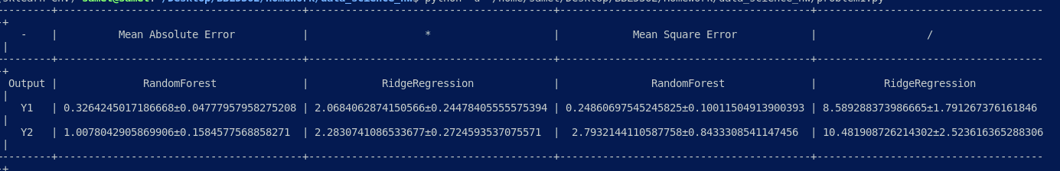

**Question 2**

The result is close like in homework. The algorithm use 20 different C for logistic regression. In this graph, increasing of C value gives best results. The auc score is came from cross_val_score.

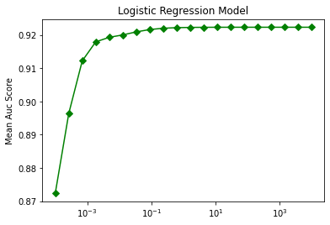

Firstly, I calculate average classification score for logistic regression with C=1. The result is close the given result. Also I get score for neural network. The model parameter come from task-3.

